NAMA : FIKRI ANGGRA BERLIAN

KELAS : X

**PENGOLAHAN FILE DAN DIRECTORY MENGGUNAKAN MS-DOS / COMMAND PROMPT DI WINDOWS**

**TRY 1 :**

1. **CHECK COMMAND PROMPT VERSION**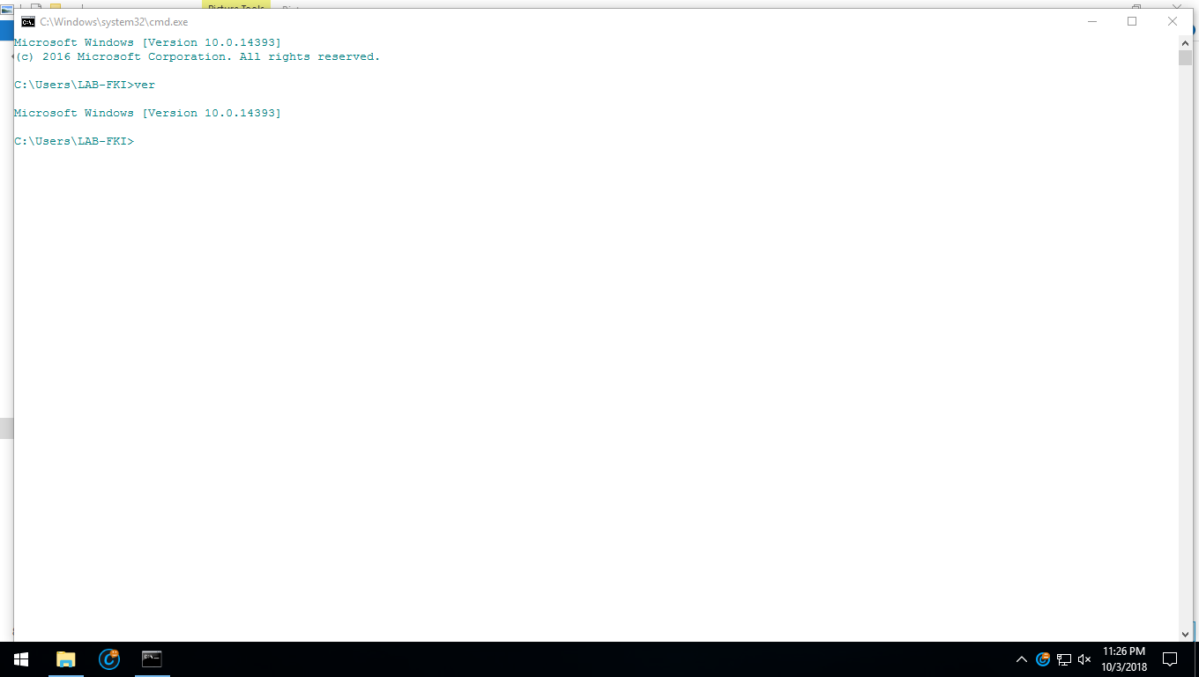

**TRY 2 :**

1. **CHECK DIRECTORY**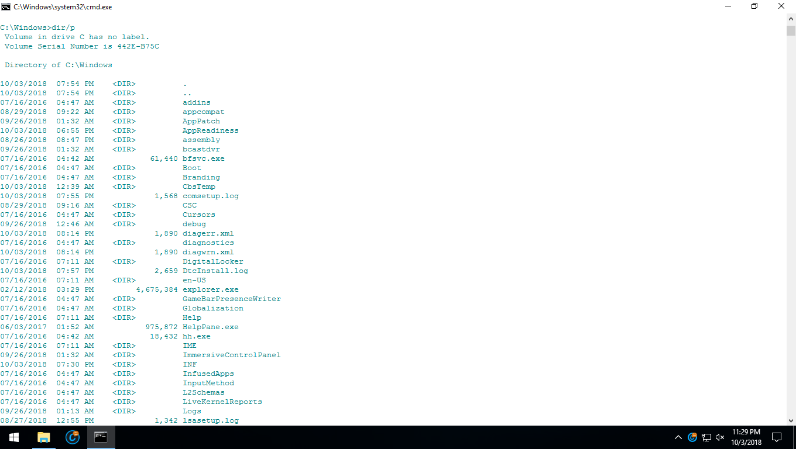
2. **DIR/P**
3. **DIR/W**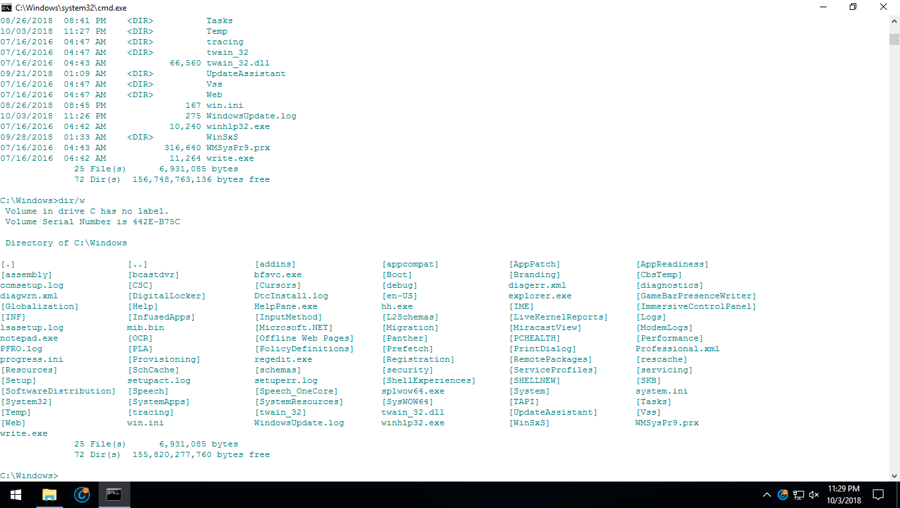
4. **DIR/A**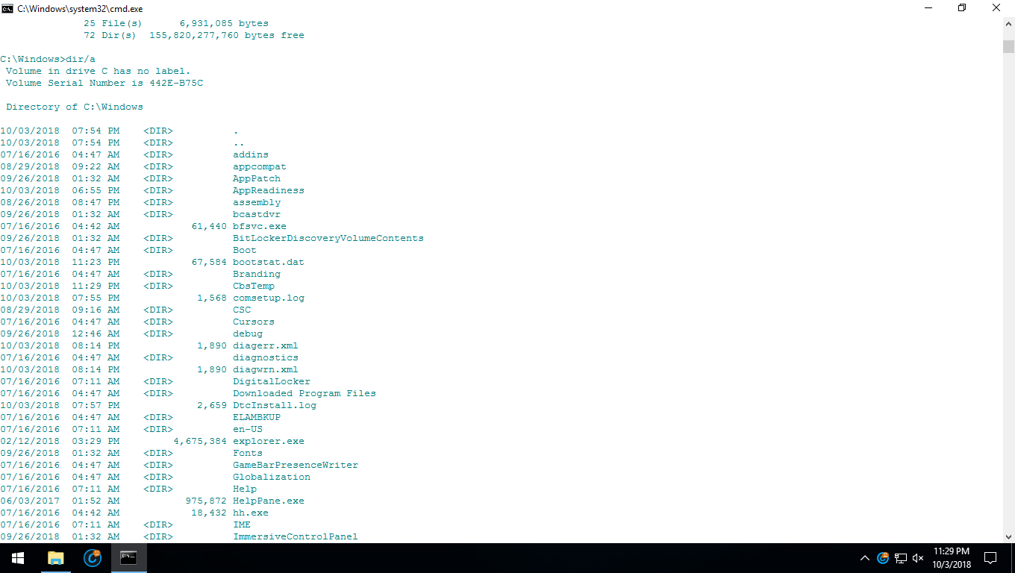

**TRY 3 :**

1. **DIR AND CD FILES**

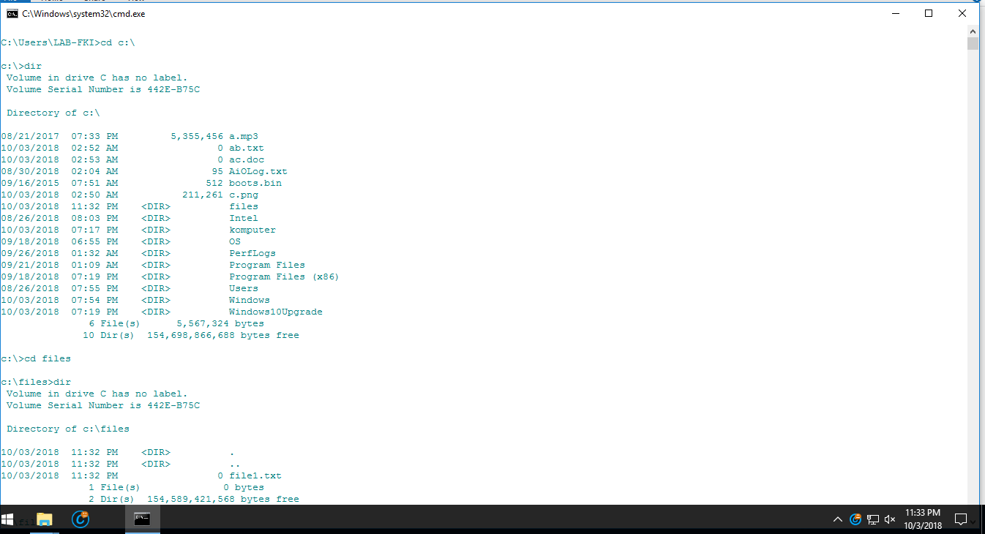

1. **MAKE FILE1.TXT AND RENAME TO FILE.TXT AND RENAME AGAIN FILE2.TXT**

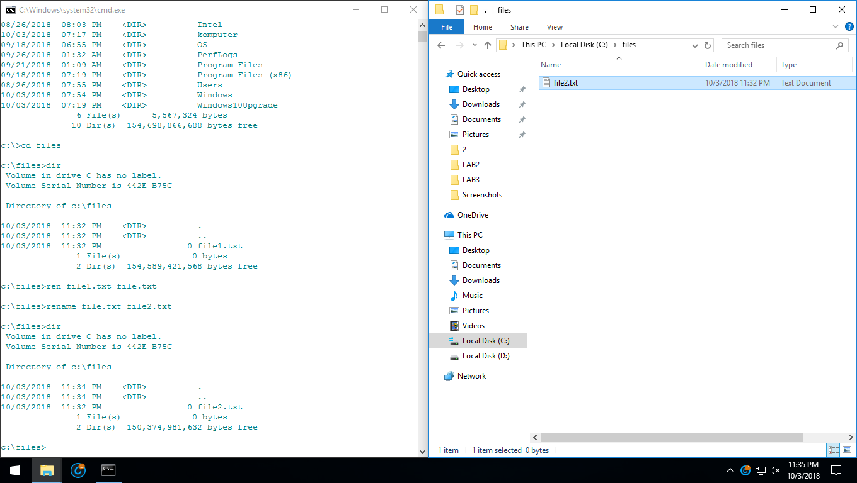

**TRY 4 :**

1. **COPY FILE2.TXT IN FILES TO NEW FILES2**

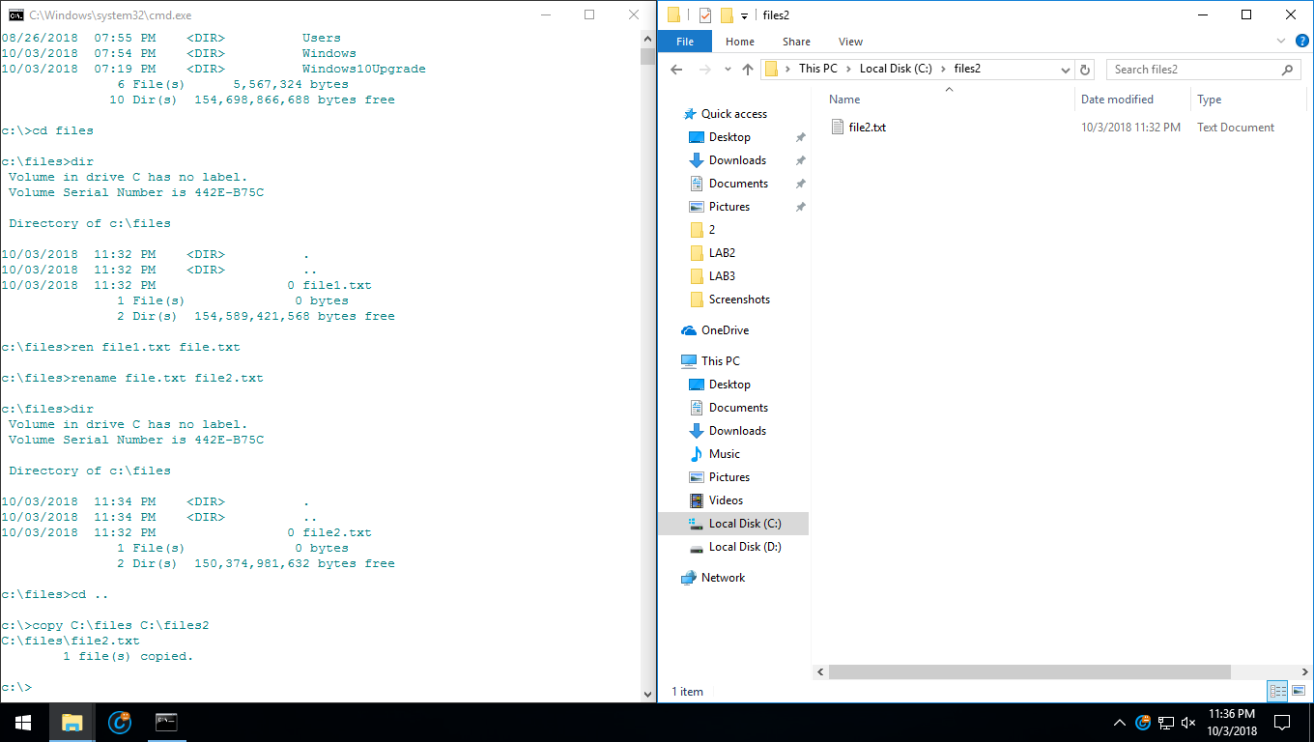

1. **COPY FILE2.TXT TO D:\**

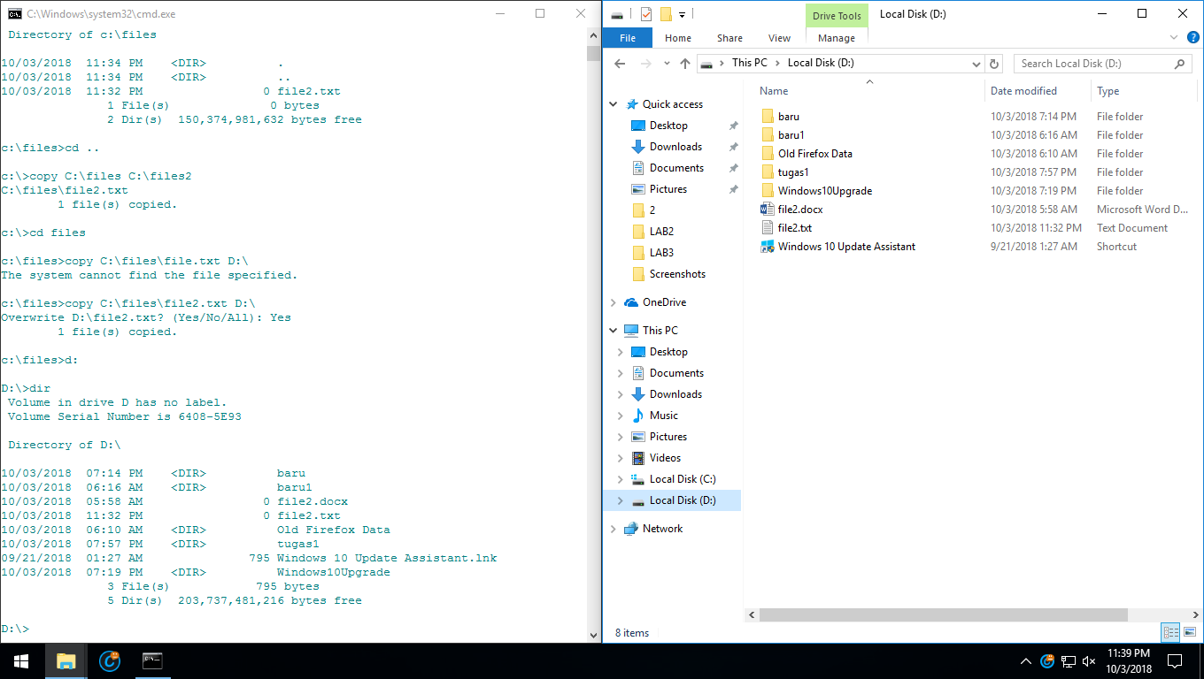

1. **COPY DEKSTOP TO BARU AND CHECK THE FILE IN BARU FOLDER**

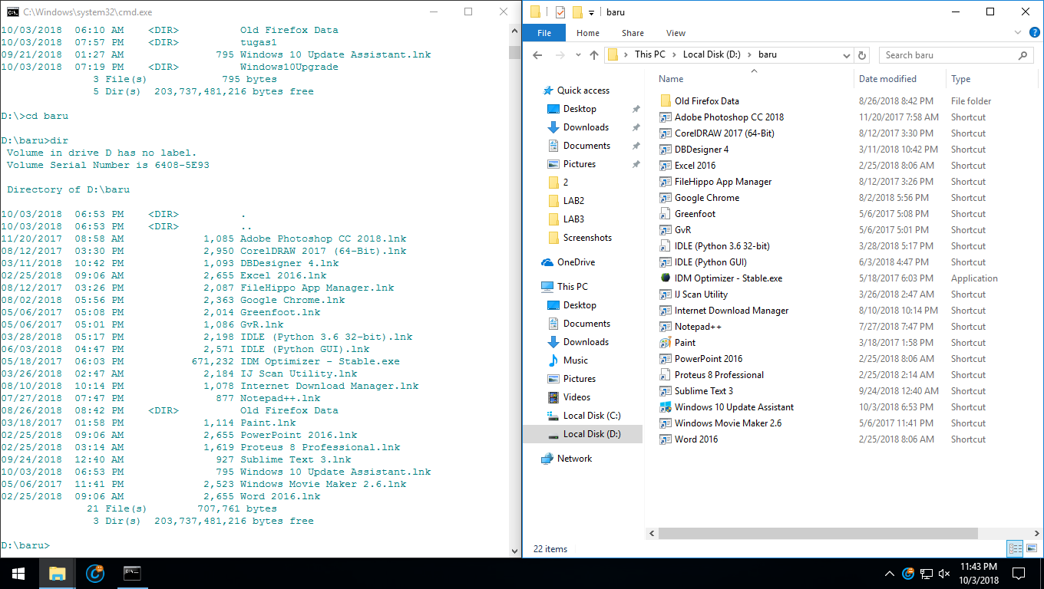

**TRY 5 :**

1. **MAKE NEW FOLDER “FILM” AND “COMPUTER”**

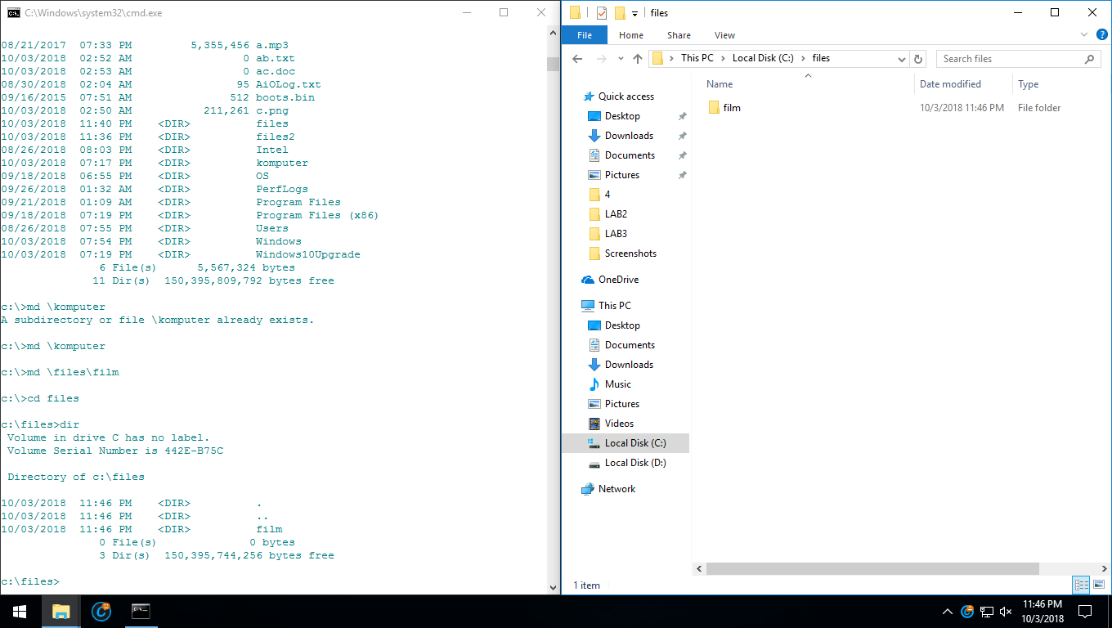

**TRY 6 :**

1. **MOVE FILE PINDAH.TXT AND PINDAH.DOC TO FILES2**

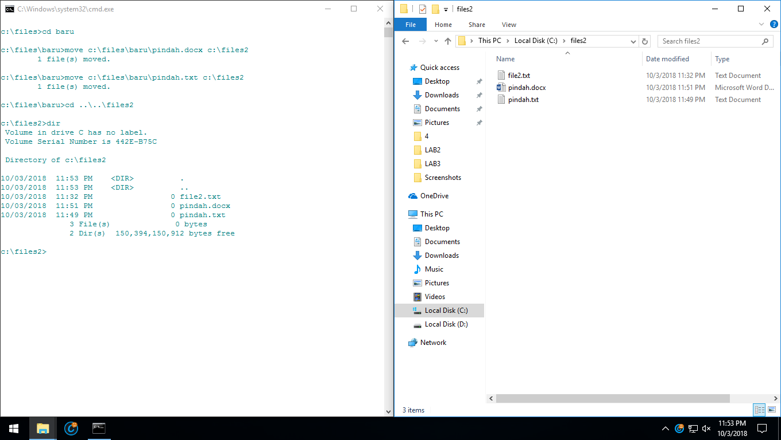

1. **SEE THE DIRECTORY FOLDER IN STRUCTURE**

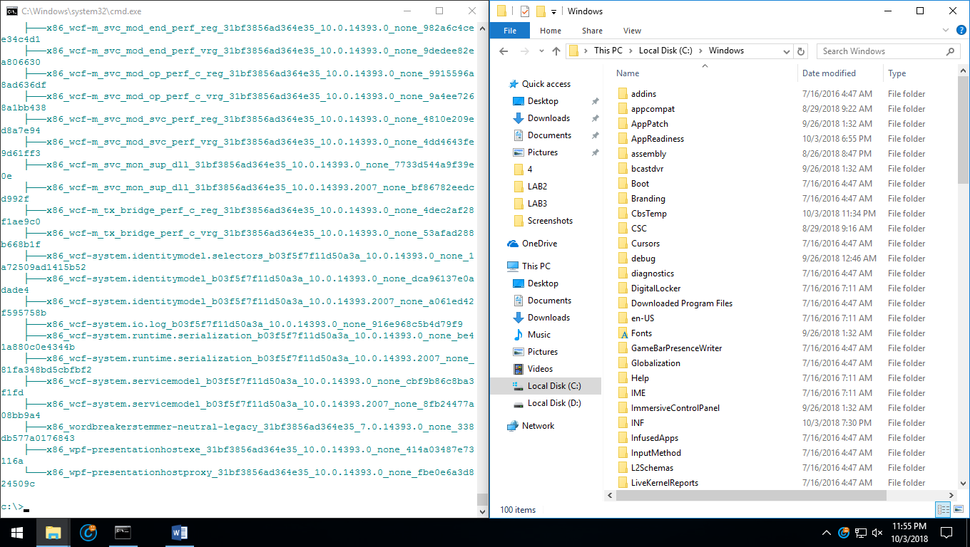

**TUGAS RUMAH :**

1. **GO TO DIREKTORI D:/ USE “D:”**

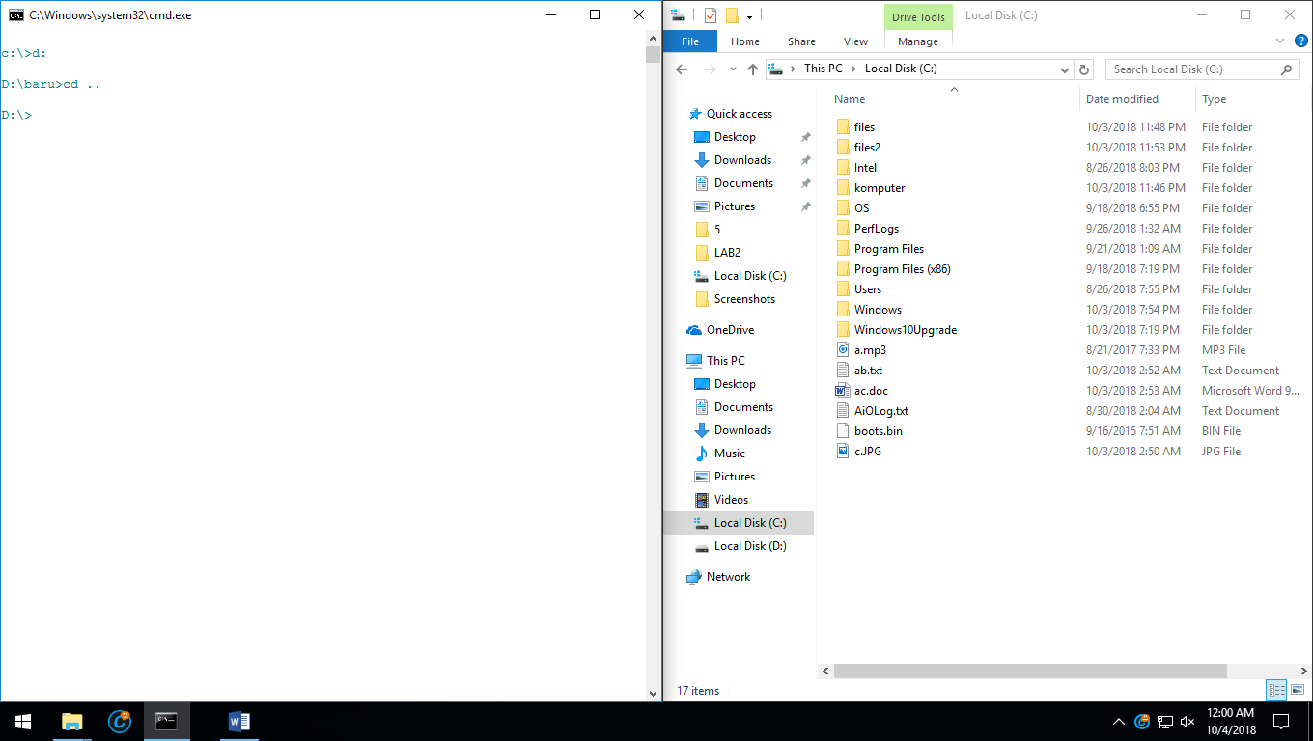

1. **AFTER MAKE NEW FILE NAME “MULTIMEDIA” IN D: THEN, GO TO C:\ AND COPY FILE THAT HAVE .MP3, .JPG, .DOC, .TXT TO D:\MULTIMEDIA**

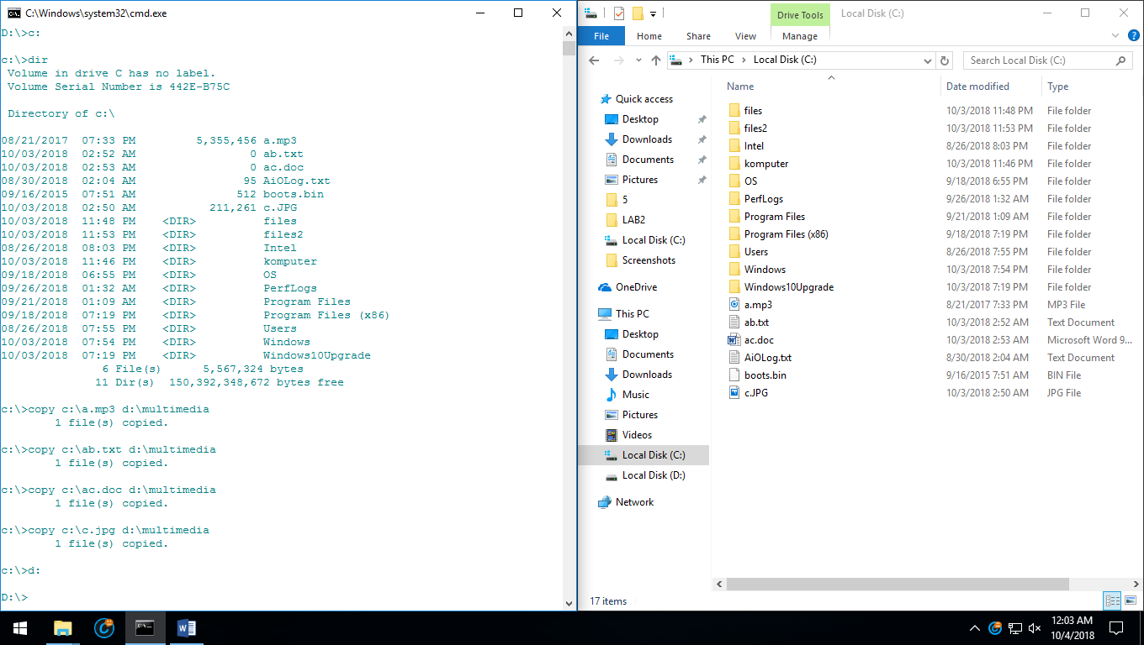

1. **GO TO D:\MULTIMEDIA AND THEN DIR FOR CHECK THE FILE THAT WE COPY BEFORE IF EXIST OR NOT**

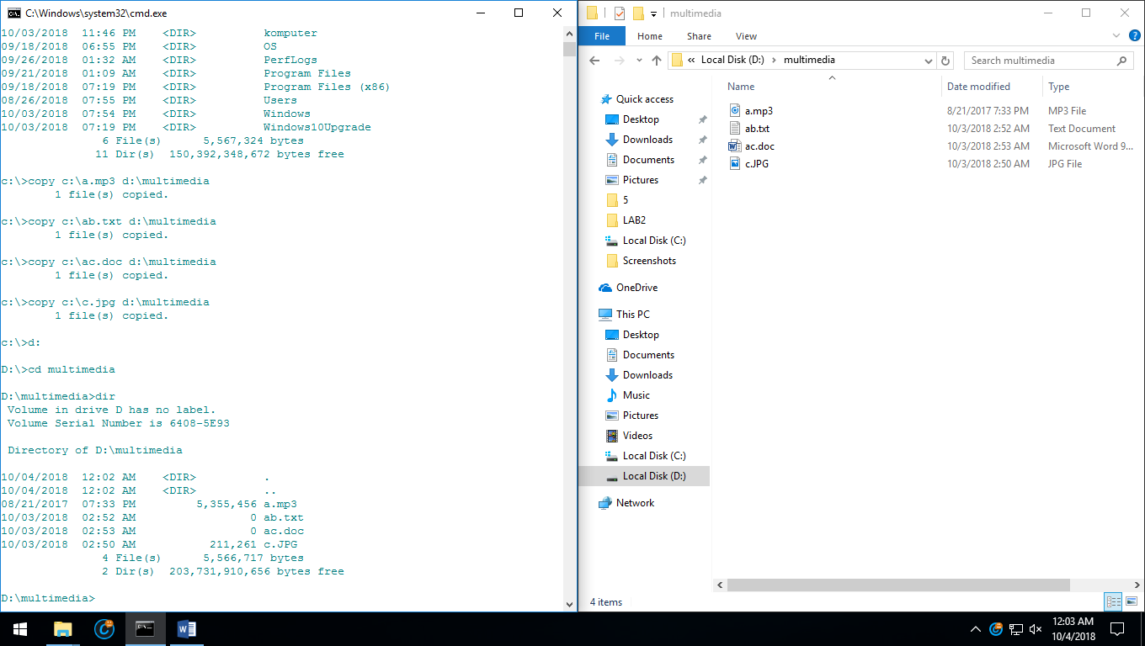

**THANK YOU**